**Create AG across Azure Region**

[Tutorial: Configure an availability group across regions - SQL Server on Azure VMs | Microsoft Learn](https://learn.microsoft.com/en-us/azure/azure-sql/virtual-machines/windows/availability-group-manually-configure-multiple-regions?view=azuresql)

**Step 1: Create new DR VNET and subnet**

192.168.0.0/16 (65,536 addresses)

Subnet

DRSUBNET (192.168.2.0/24) (256 addresses)

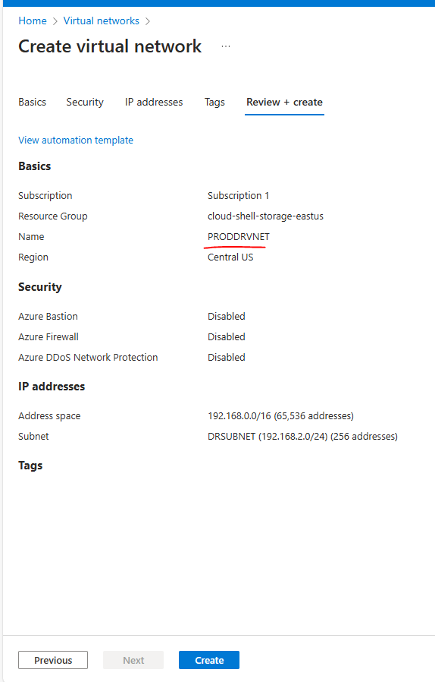

**Step 2: Create DR Availability set**

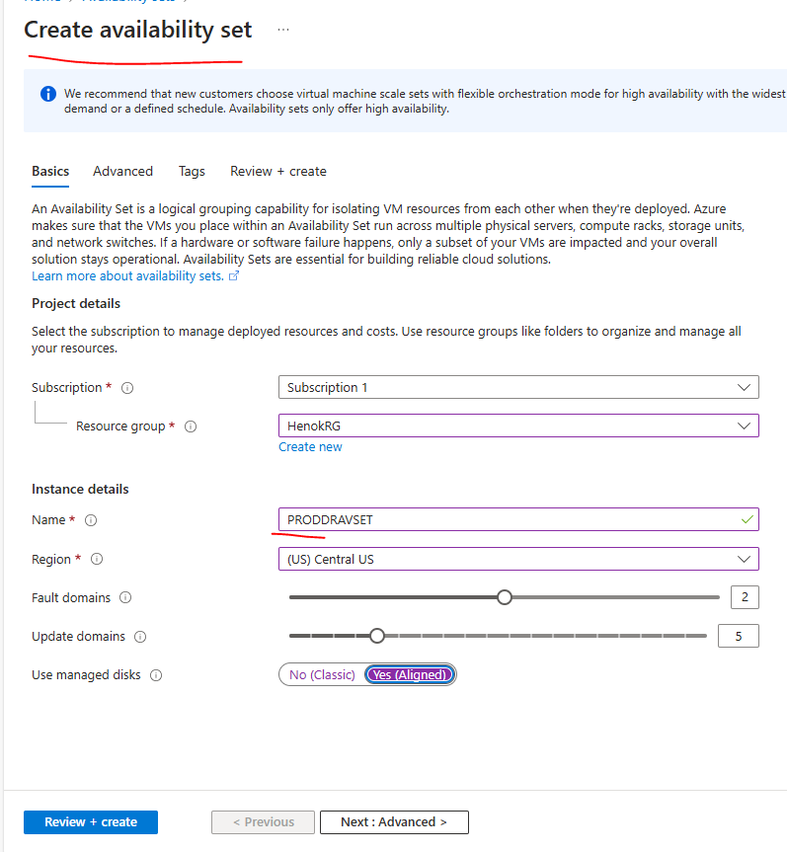

**Step 3: Create DR VM (make sure you use the right Avset and subnets in DR region)**

* **Change the ip address to static**

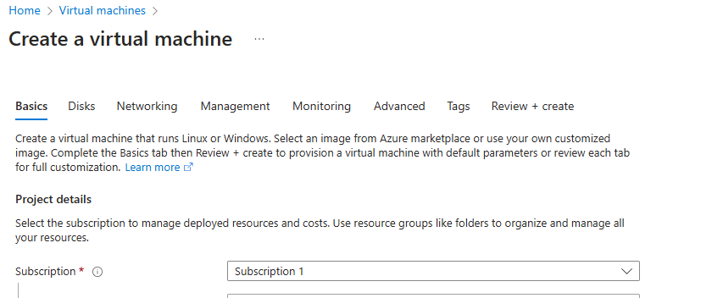

**Step 4: create VNET PEERING**

Open one of the Vnets and configure “Peering” – ADD -

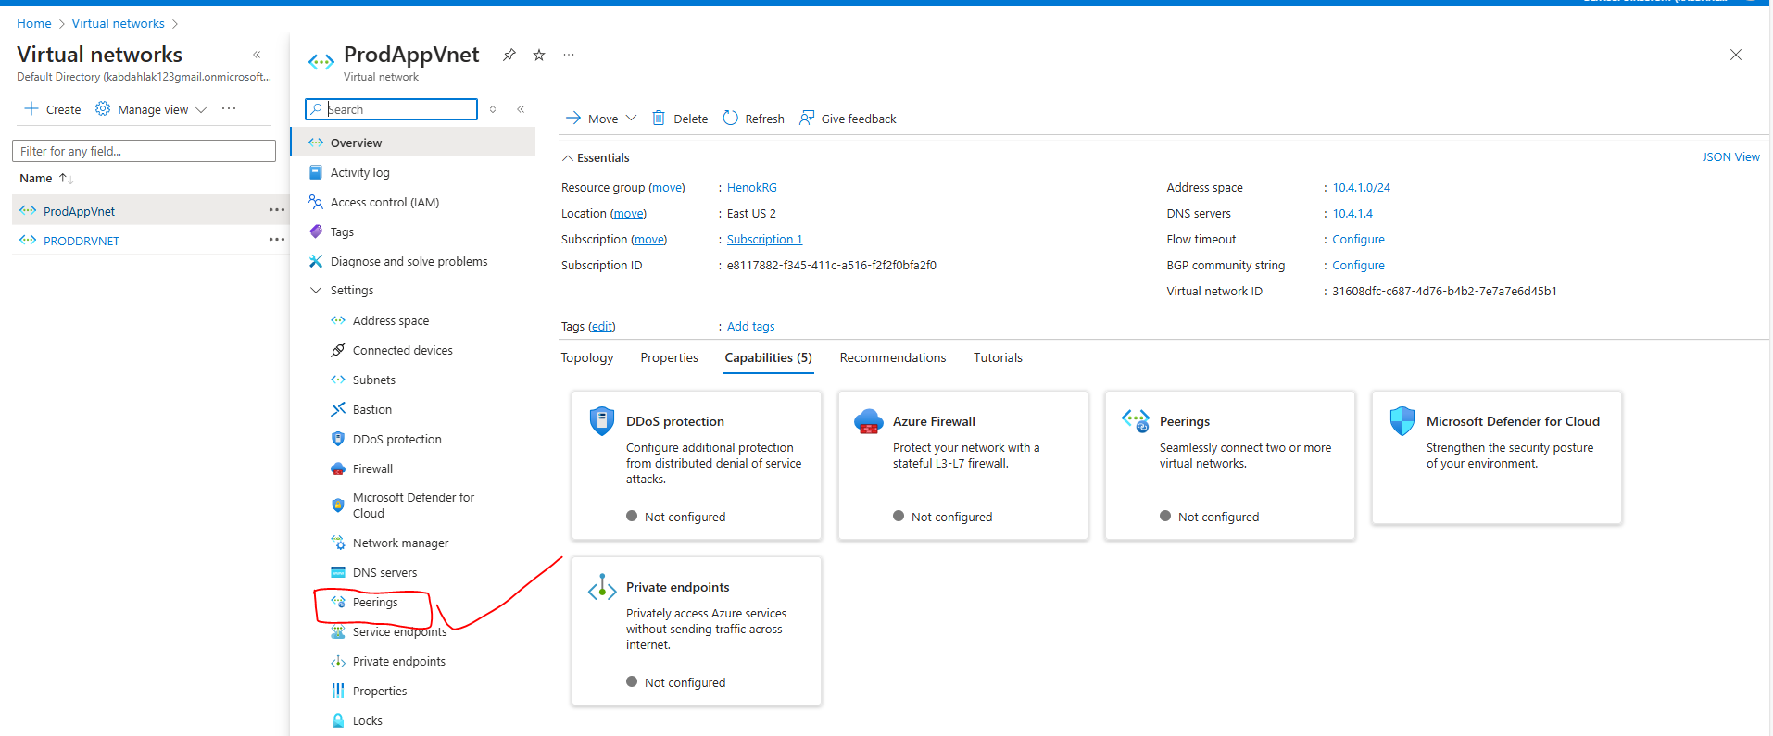

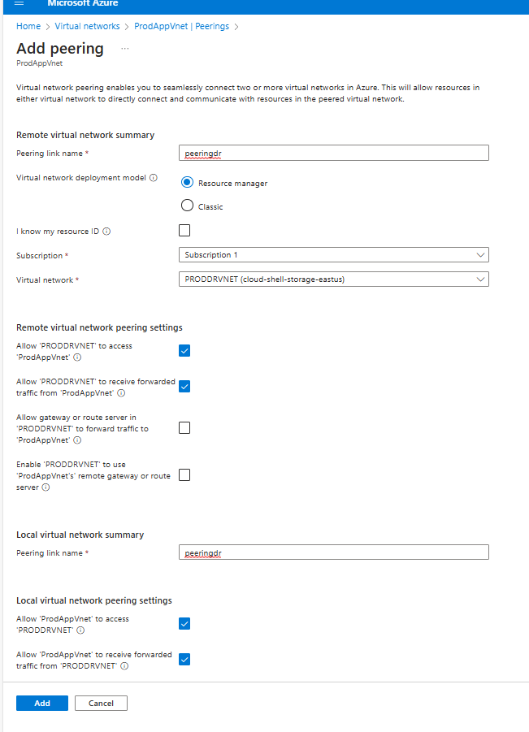

**Step 5 Create Domain controller VM in DR site**

* Use the same dr vnet and availability city with the previous VM
* Change ip address to static
* Add the primary node’s DC IP address in the DNS record.
* Restart after registering the DNS of the primary DC

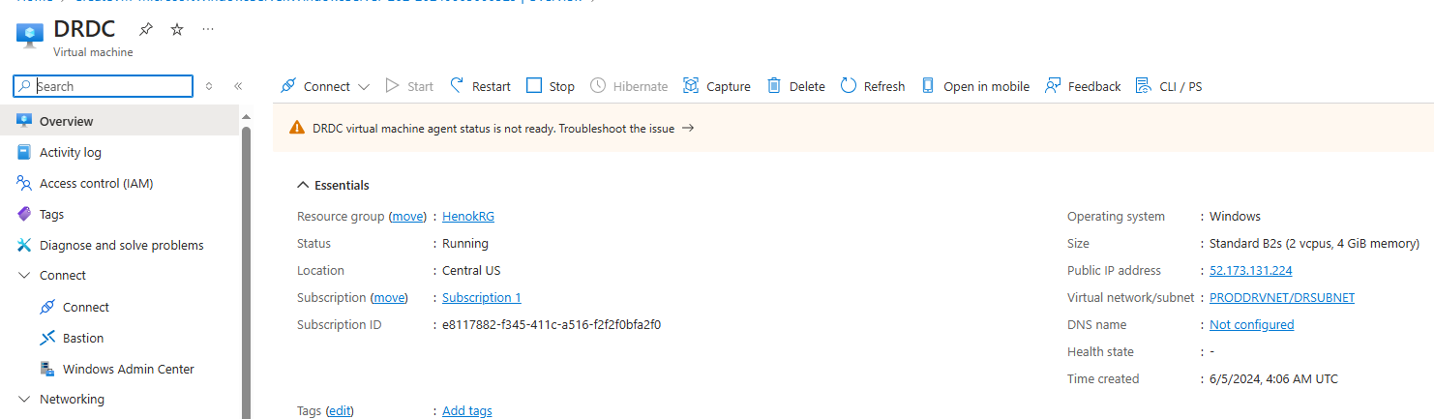

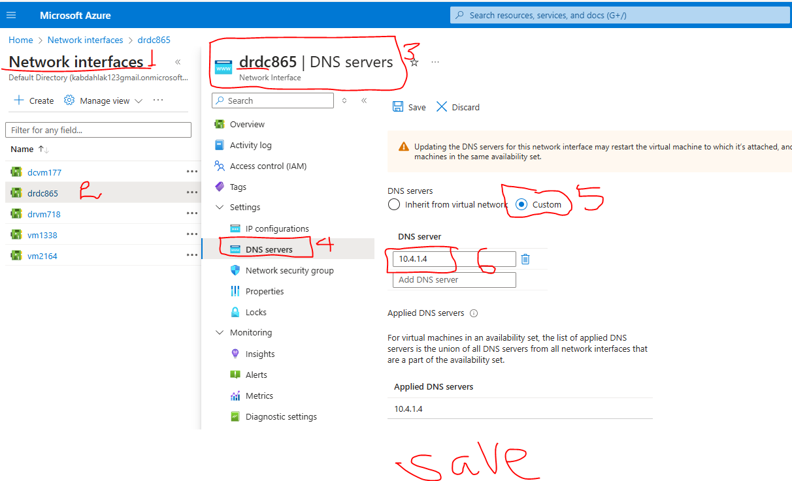

**Step 6: Join the DR DC VM to the main domain (prod.com) and promote it to a domain controller** by adding “Roles and features” under server manager.

* This is needed for authentication when the primary DC fails

Join domain

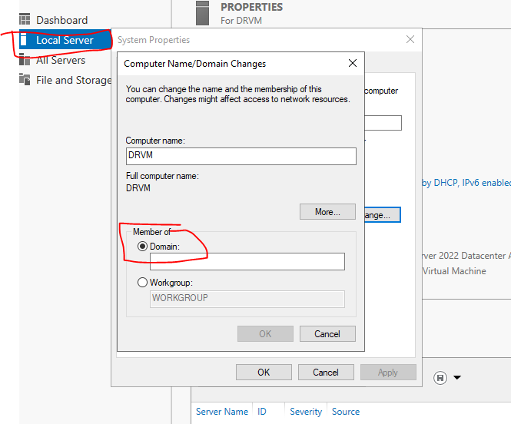

Add role

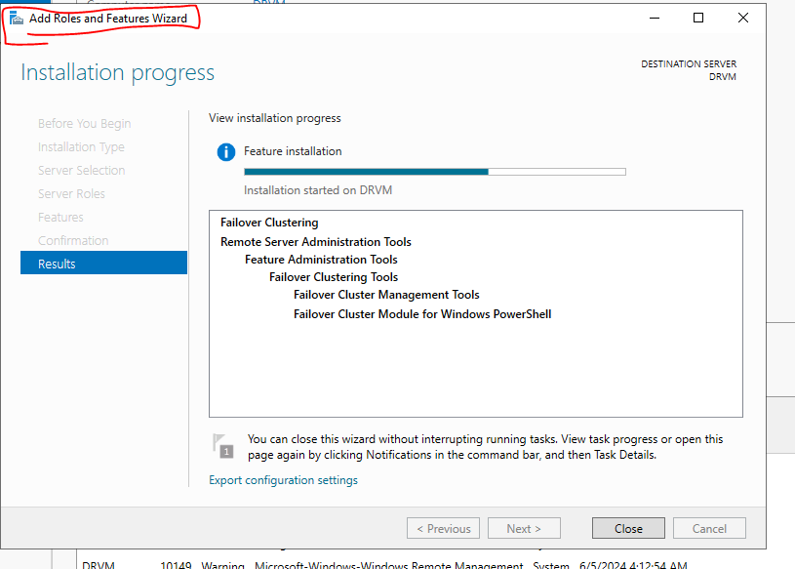

Promote to DC

Restart

**Step 7: DR replica node – add to domain and add failover cluster feature**

(I tried to add it to the domain before the DR DC was promoted to DC and it failed. I added failover cluster and restarted it, by that time the DR DC node was promoted to DC..so after restart I was able to join the domain prod.com)

**Step 8: Add DR replica node to the Cluster and SQL configurations**

* **Add** the **DR Node into the cluster** from the primary servers (e.g.VM1)
* **Install SQL and SMSS. Enable TCP** on sql configuration manager.
* Once added to the cluster, **enable alwayson** feature
* **Restore database with NORECOVERY**
* While adding to the cluster, do not check “shared storage” option!

Joining

Joined

Always on feature enabled

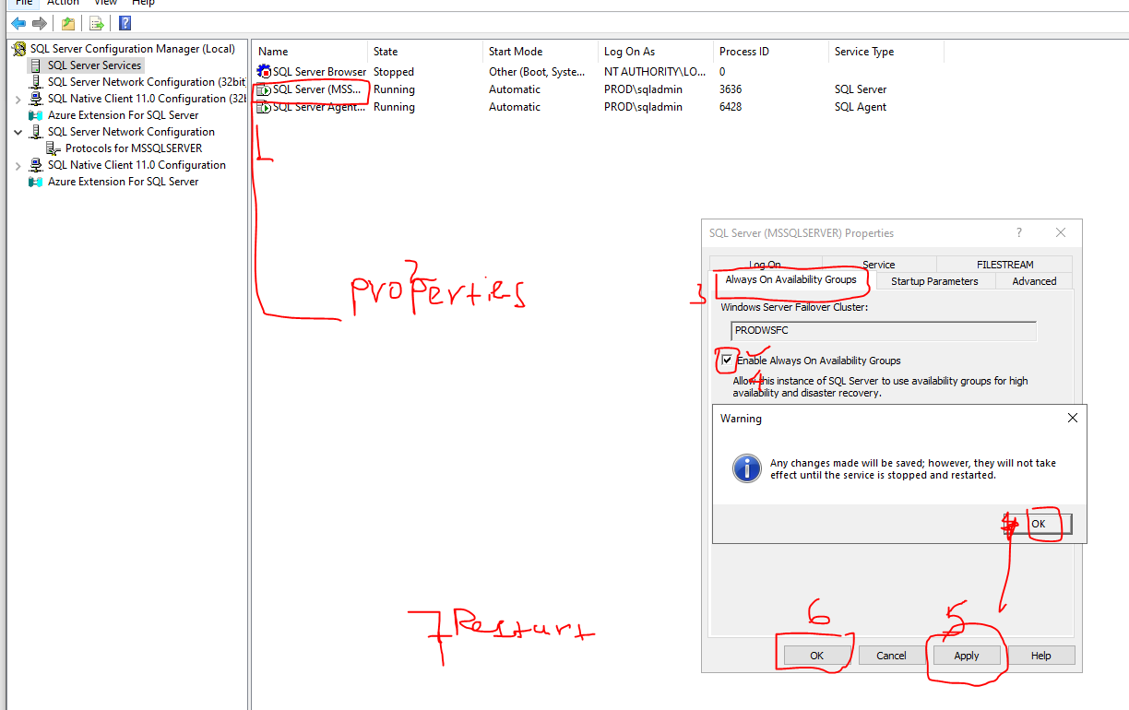

**SQL Account permissions to create AG**

--create NT account (if exists, grant the permission and skip this)

USE [master]

GO

CREATE LOGIN [NT AUTHORITY\SYSTEM] FROM WINDOWS WITH DEFAULT_DATABASE=[master]

GO

--Grant NT account permissions

GRANT ALTER ANY AVAILABILITY GROUP TO [NT AUTHORITY\SYSTEM]

GO

GRANT CONNECT SQL TO [NT AUTHORITY\SYSTEM]

GO

GRANT VIEW SERVER STATE TO [NT AUTHORITY\SYSTEM]

GO

**Finally, restore the database in DR node with NORECOVERY**

**Step 8: Adding IP address to Cluster and AG Listener (skip adding IP to cluster, focus on DR AG listener IP)**

**In our case there is no need to add IP to the cluster, but the listener will need one.**

**We can add the DR listener IP using the SSMS that simplifies the need to add the new listener IP to AG Listener name.**

For information: Look the configuration in DNS – it appears the distributed server name has 3 servers, DNN Listener also has 3. But VNN listener has only 1.

Since we are using window 2019 and distributed server name registers the new DR node in the DNS, there is no need to register the IP of the new Node into the cluster.

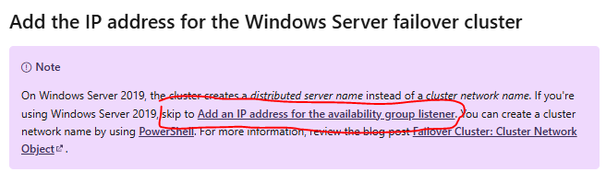

If a cluster was built with 2016 windows, we have to add the IP address to the cluster. Use the step below

**To Add secondary Listener IP (for 2019 windows SKIP this step)**

First add new IP resource e.g. 192.168.2.10 – **this will be listener (Load balancer Ip for DR)**

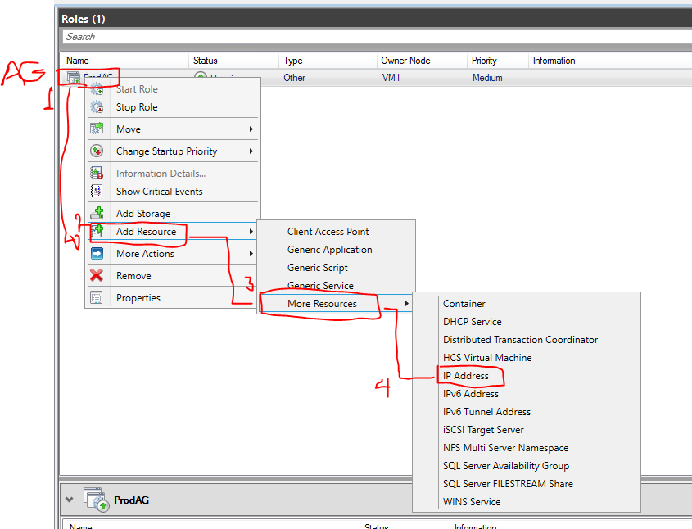

Then configure this new IP resource (rewrite the NAME e.g. IP adress then IP)

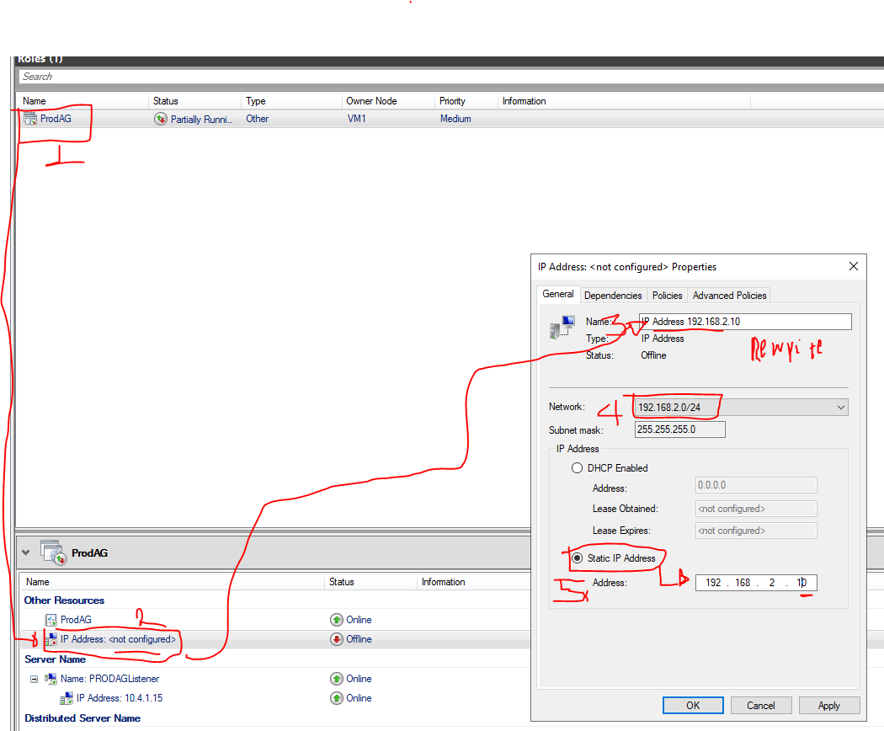

But since I used VNN listener the AG listener has to add a new listener IP (frontip of load balancer in the DR region)

**Adding DR Listener IP to the AG Listener**: the simplest way is to add the listener IP using SSMS, it will register in the cluster and create a dependency in the AG listener inside the cluster.

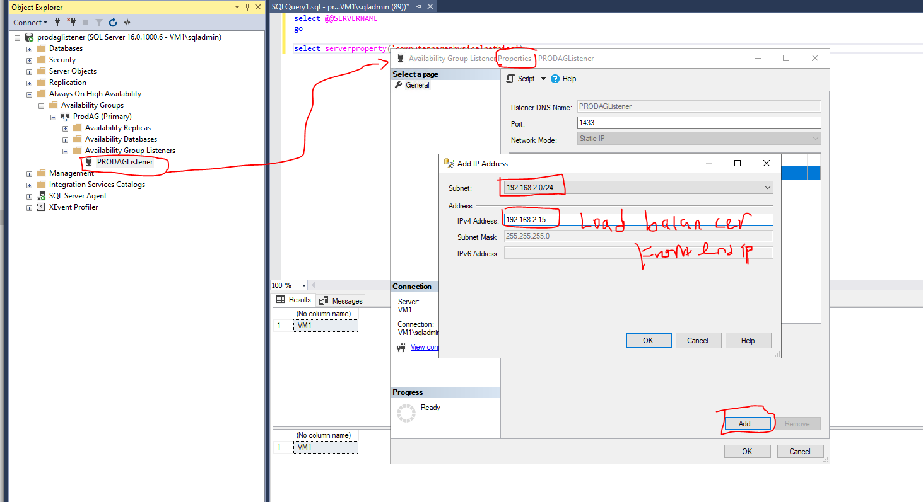

Check from the cluster: it is created and the dependency is also registered.

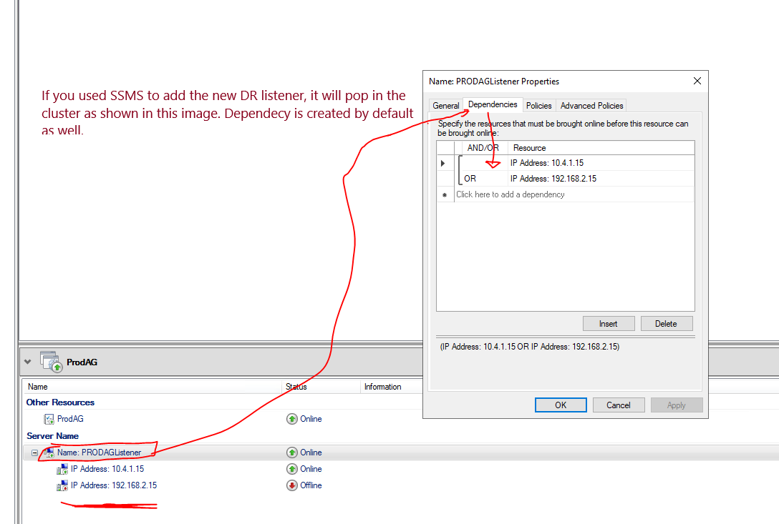

If you want to add the listener from the cluster, you have to create the dependency by yourself.

**Step 9: Add DR node as a replica.**

After database restore is done, add DR node into the availability group.

Connect to the Primary Node (HA) – Add Replica – Specify Replica – Asynchronous

Since we restored the database we choose “JOIN”.

**At this stage we can do failover to the DR region but connecting from a different node using a listener will not work because we haven’t configured the Load balancer Powershell for VNN listener.**

Follow below

**Step 10: create Load balancer for the DR site and RUN Powershell Script to register VNN Lister**

**(follow the same step for Load balancer and VNN registration provided in previous documents)**

Frontend = listener (that is registered/to be registered in AG listener)

Backend = the DR node

Give new port number and register it in firewalls.

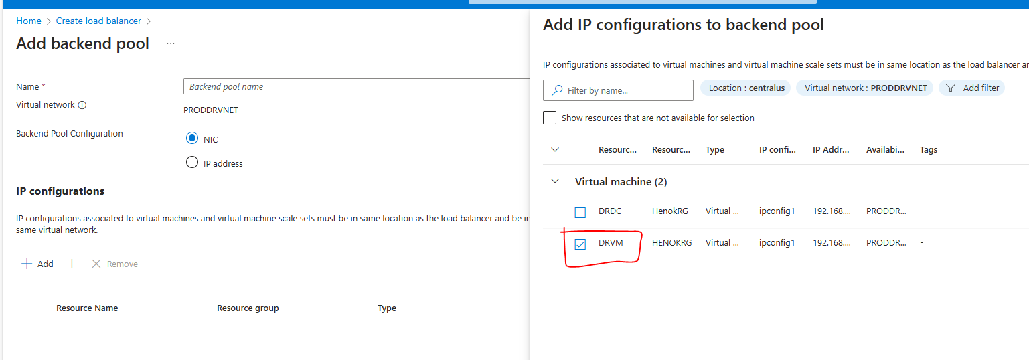

**PowerShell script**

Make sure there are no improper spaces e.g.

" ProdAG_192.168.2.15" this works but

" ProdAG_192.168.2.15" this fails because of the space at the beginning

PowerShell script: **run on the DR node participating in the AG**

**----------**

$ClusterNetworkName = "Cluster Network 2"

$IPResourceName = " ProdAG_192.168.2.15"

$ILBIP = "192.168.2.15"

[int]$ProbePort = 59999

Import-Module FailoverClusters

Get-ClusterResource $IPResourceName | Set-ClusterParameter -Multiple @{"Address"="$ILBIP";"ProbePort"=$ProbePort;"SubnetMask"="255.255.255.255";"Network"="$ClusterNetworkName";"EnableDhcp"=0}

-----------

**Changes:**

Clusternetworkname is Cluster Network 2

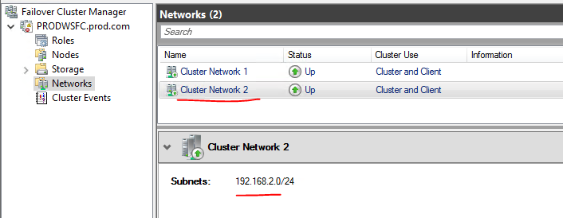

$IPResourceName and $ILBIP

int]$ProbePort : I used the same port 59999

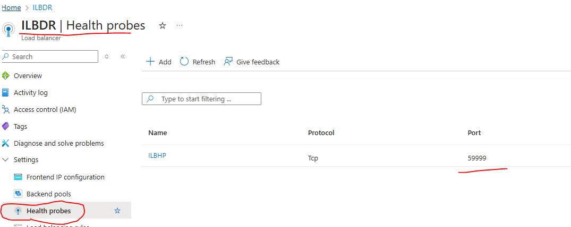

**After you run the PowerShell script, set the listener IP of the DR to Offline and then bring it Online. Bring the AG ONLINE as well.**

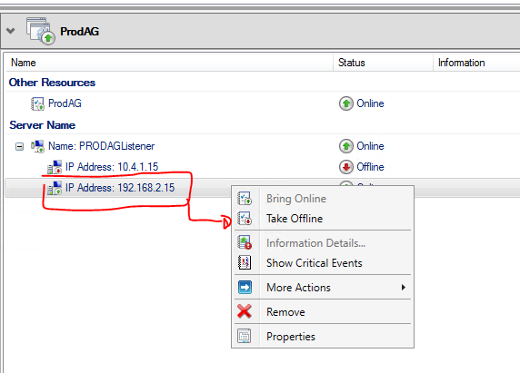

**Now ALL work well. If you have an account with proper permission in each VM, then you can connect from any node using the listener.**

**Testing failover**

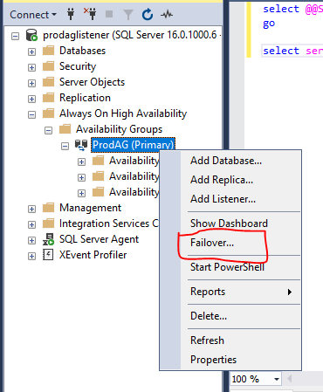

**After Failover to the DR site, testing Listener from the DC**

